1. **What are the difference between Pivot Charts Vs Regular Charts**

Answer: While Pivot Charts are amazing and come with the ability to update when the Pivot Table updates, these are not as flexible as the regular charts.

In general, you can do a lot of customization in a regular Excel chart, but not in a Pivot chart. Also, if you customize a Pivot Chart, and then update the Pivot Table, you are likely to lose the customization.

Despite the limitations, Pivot Charts are useful and can help create quick views from a Pivot Table.

1. **What are slicers? what is the use ~~if~~ of it?**

Answer: Slicers are a form of filters which are used along with the Pivot feature. Slicers can be of two types 1. Timeline 2. Attribute selections. Apart from filtering, slicer provides direct buttons on the screen to apply and remove filters. One slicer can be connected to multiple reports and charts unlike Filter. This makes dashboard interactive, easy to drill-down and User friendly

**3.How many report formats are available in MS Excel?**

Answer: There are three report formats in MS Excel – compact, report, and tabular.

4. What are appropriate charts you should use for a ‘Regionwise Sales report”, and why?

Answer: Based on unique name of regions, Bar chart, Column chart or pie chart can be chosen.

5. Lists the types of charts, and when they should be preferred ?

If you have categorical data, use a bar chart if you have more than 5 categories or a pie chart otherwise.

If you have nominal data, use bar charts or histograms if your data is discrete, or line/ area charts if it is continuous.

If you want to show the relationship between values in your dataset, use a scatter plot, bubble chart, or line charts.

If you want to compare values, use a pie chart — for relative comparison — or bar charts — for precise comparison.

If you want to compare volumes, use an area chart or a bubble chart.

If you want to show trends and patterns in your data, use a line chart, bar chart, or scatter plot.

1. You want to define a reusable process to reshape data (removing blank rows, merging columns, etc.). What tool can you use to accomplish this?
   1. **Power Query**
   2. Data Analysis
   3. Power Pivot
   4. Data Modeler
2. You want to add a column to the PivotTable below that shows a 5% bonus for each sales rep. That data does not exists in the original data table. How can you do this without adding more data to the table?  
   [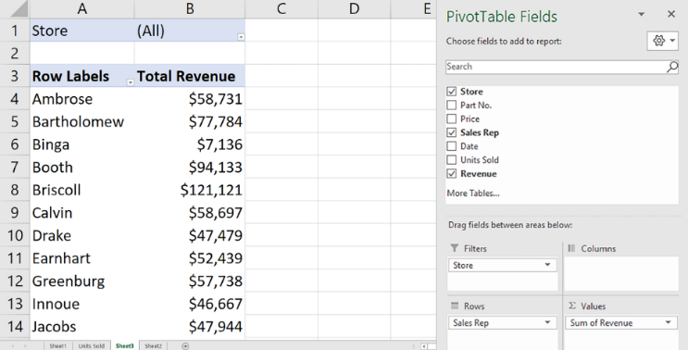](https://github.com/Ebazhanov/linkedin-skill-assessments-quizzes/blob/main/microsoft-excel/images/Q54.png?raw=png)
   1. Add a new PivotTable field.
   2. Add a calculated item
   3. Add a new Summarize Value By field.
   4. **Add a calculated field.**
3. . The PivotTable below has one row field and two column fields. How can you pivot this table to show the column fields as subtotals of each value in the row field?
   1. On the PivotTable itself, drag each Average field into the row fields area.
   2. Right-click a cell in the PivotTable and select PivotTable Options > Classic PivotTable layout.
   3. **In the PivotTable Fields pane, drag Sum Values from the Columns section to a** **location below the field in the Rows section.**
   4. In the PivotTable Fields pane, drag each field from the Sum Values section to the Rows section.
4. In this PivotTable, the continuous variable weight is shown in the Row field. Another continuous variable is in the Sum Values field. It is important to reduce a long list of body weights to a smaller set of weight categories. How do you do this?
   1. **Use weight as a filter field as well as a row field in the PivotTable.**
   2. Use IF() to show weight by categories instead of by pounds.
   3. Click the Row Labels arrow and select Group.
   4. Right-click any row field value in the PivotTable and select Group
5. How can you drill down into a PivotTable to show details?
   1. Select the cell into which you want to drill down, right-click, and select Show Summary.
   2. Select the cell into which you want to drill down, right-click and select Drill-down.
   3. **Select the cell into which you want to drill down and double-click.**
   4. Select the cell into which you want to drill down, right-click and select Show Details > Summary Page
6. How would you connect the slicer to more than 1 PivotTables?
   1. You cannot use one slicer for two PivotTables.
   2. Right-click the slicer and select Slicer Settings.
   3. Merge the two PivotTables, right-click the merged PivotTable, and select Combine Slicer.
   4. **Right-click the slicer and select Report Connections, or click Report Connections on the Slicer tab.**
7. What should be done to create following PivotTable? Fill in the blanks: Drag the ___ field to the Rows area and the ___ field to the Values area?  
   [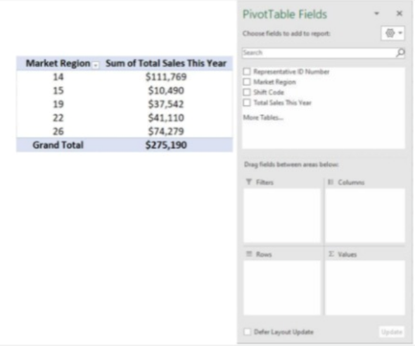](https://github.com/Ebazhanov/linkedin-skill-assessments-quizzes/blob/main/microsoft-excel/images/Q95.png?raw=png)
   1. Total Sales This Year; Total Sales This Year
   2. Total Sales This Year; Market Region
   3. Representative ID Number; Total Sales This Year
   4. **Market Region; Total Sales This Year**
8. Which of the following is NOT a box in the PivotTable Fields List?
   1. A. Column LabelsB. Report FilterC. Values **D. Formulas**
9. Under which tab and in which function group will you find the option to insert a Pivot Table?
   1. **Under the Insert tab in the Tables group**
   2. [B.](javascript:%20void(0)) Under the Formulas tab in the Data Analysis group
   3. [C.](javascript:%20void(0)) In the Data group in the Pivot Tables group
   4. [D.](javascript:%20void(0)) In the Data group in the Tables group
10. Which pivot table layout allows dragging fields to the grid in a spreadsheet?
    1. Default Pivot Table Layout
    2. **Classic Pivot Table Layout**
    3. Master Pivot Table Layout
    4. Operation Geronimo Layout
11. For a table to work properly, the top row should have column headings. Yes or no?
    1. **Yes**
    2. No, only rows may have headings.
    3. No
    4. Can't say
12. Pivot tables that have been created can easily be turned into graphs or charts by simply highlighting the whole pivot table and choosing a graph or chart that you want to create. Is this true?
    1. **True**
    2. False, pivot tables do not contain enough information for graphs or charts
    3. False, only regular tables may be used to create graphs or charts
    4. False

1. Which of these is NOT included in the PivotTable Field List pane?
   1. Column Labels
   2. Values
   3. Report Filter
   4. **Formulas**
2. The first step in creating a Pivot Table is:
   1. Clicking on the Insert Tab and inserting a Pivot Table
   2. **Select data that needs to be analyzed.**
   3. Deciding on which fields to use to analyze the data.
   4. None of the above
3. What is a Pivot Table?
   1. a) A table containing data that is organized horizontally.
   2. b) A table used to calculate financial pivot values.
   3. **c) A tool used to summarize data.**
   4. d) A table containing only black, grey and white formatting.
4. Where is a Pivot Table inserted?
   1. a) Below the last row of data in your worksheet.
   2. b) Next to the last column of data in your worksheet.
   3. **c) It depends on whether you select to insert the Pivot Table in the current worksheet or a new worksheet and where your cursor is.**
   4. d) Above the first row of data in your worksheet